Module-2 Assignment

### **Problem Statement:**

You work for Xyz Corporation. Your corporation is working on an application and they require secured web servers on Linux to launch the application.

## You have been asked to:

1. Create an Instance in us-east-1 (N. Virginia) region with Linux OS and manage the requirement of web servers of your company using AMI
2. Replicate the instance in us-west-2 (Oregon) region
3. Build two EBS volumes and attach them to the instance in us-east-1 (N. Virginia) region
4. Delete one volume after detaching it and extend the size of other volume
5. Take backup of this EBS volume
6. Created an Instance in us-east-1 (N. Virginia) region with Linux OS and manage the requirement of web servers of your company using AMI.

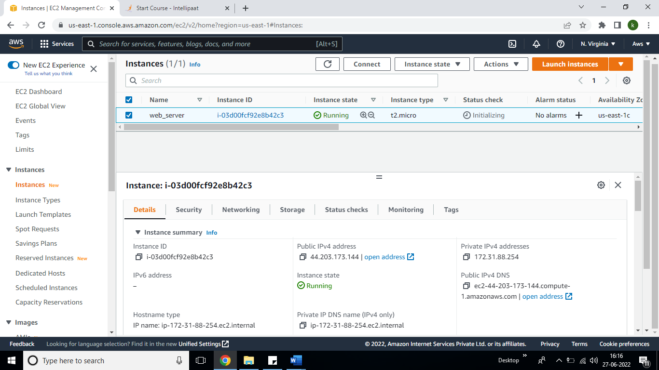

We have installed httpd.

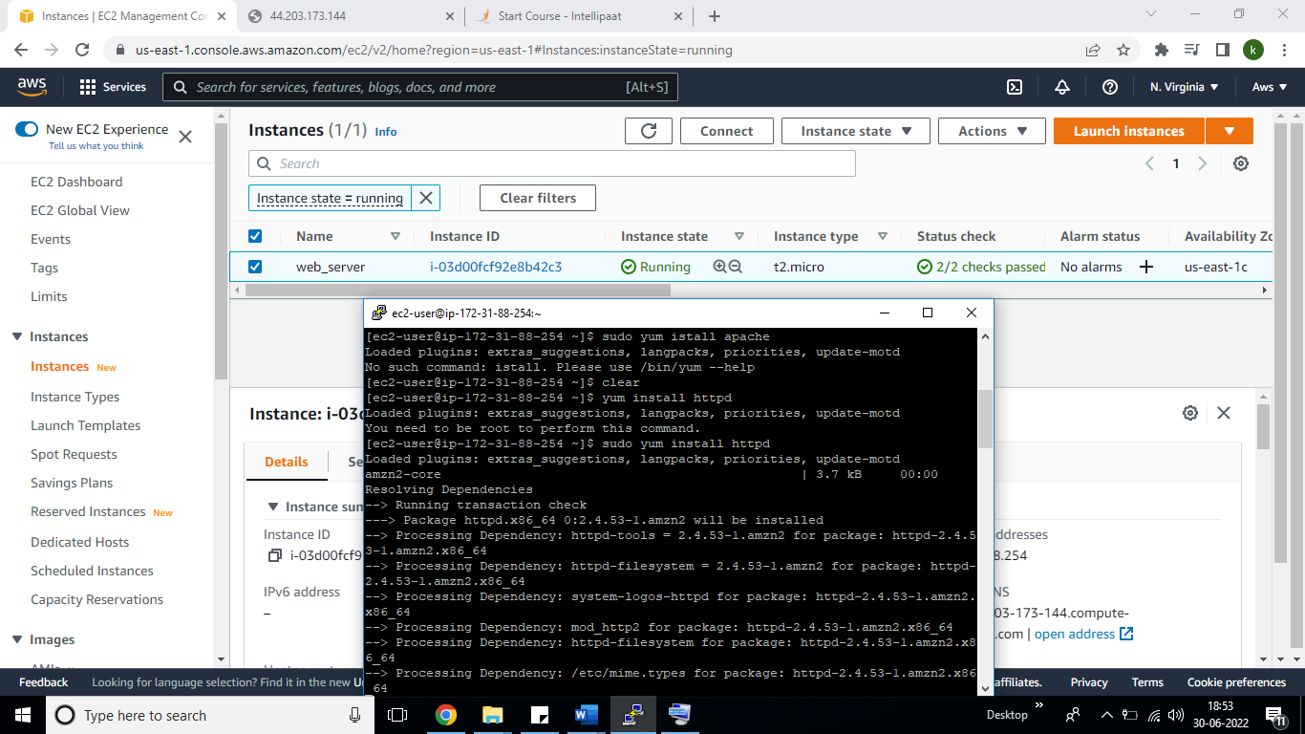

1. Replicate the instance in us-west-2 (Oregon) region

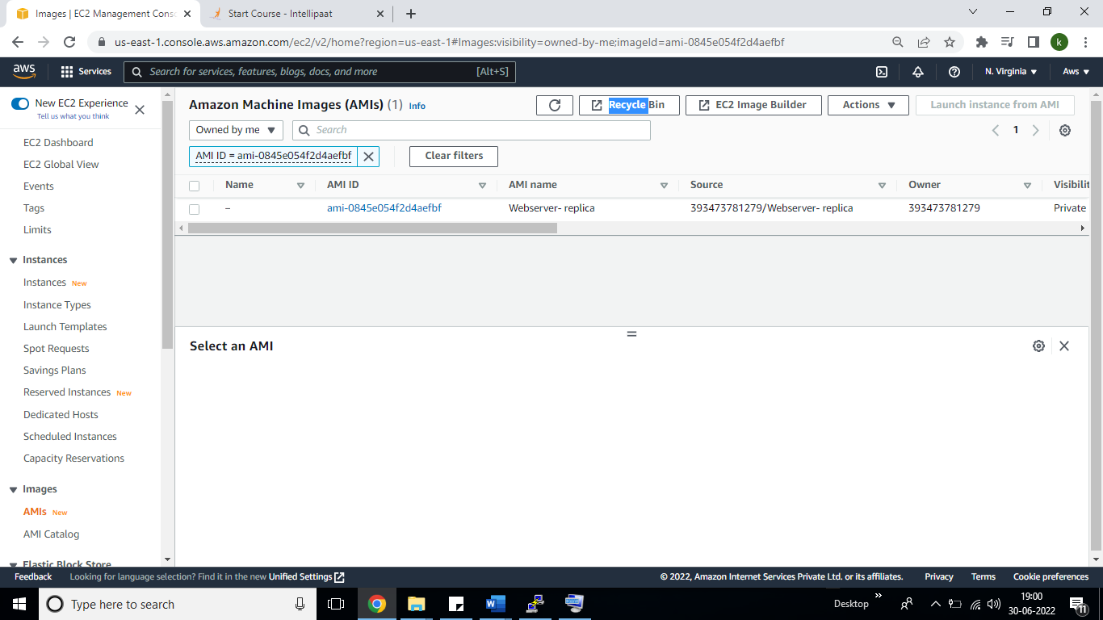

Created Replicate server us-west-2 (Oregon) region-

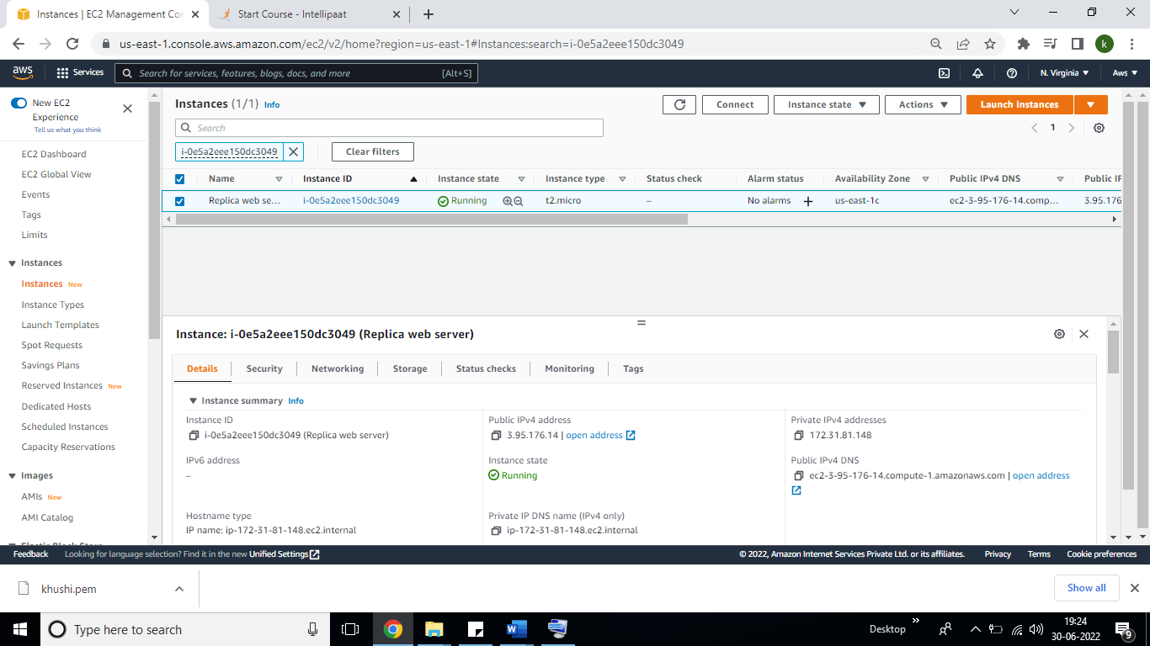

Create volume:-

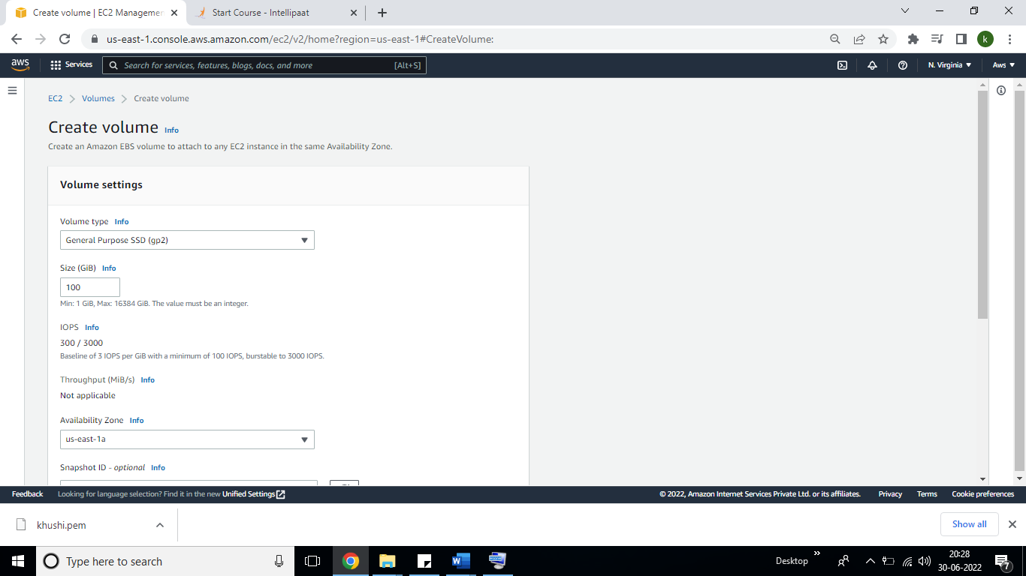

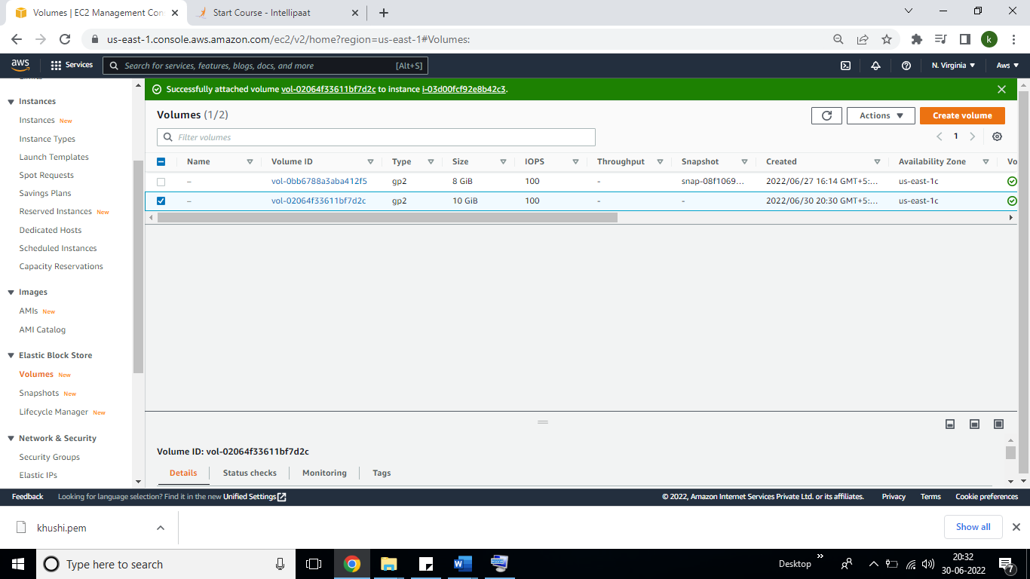

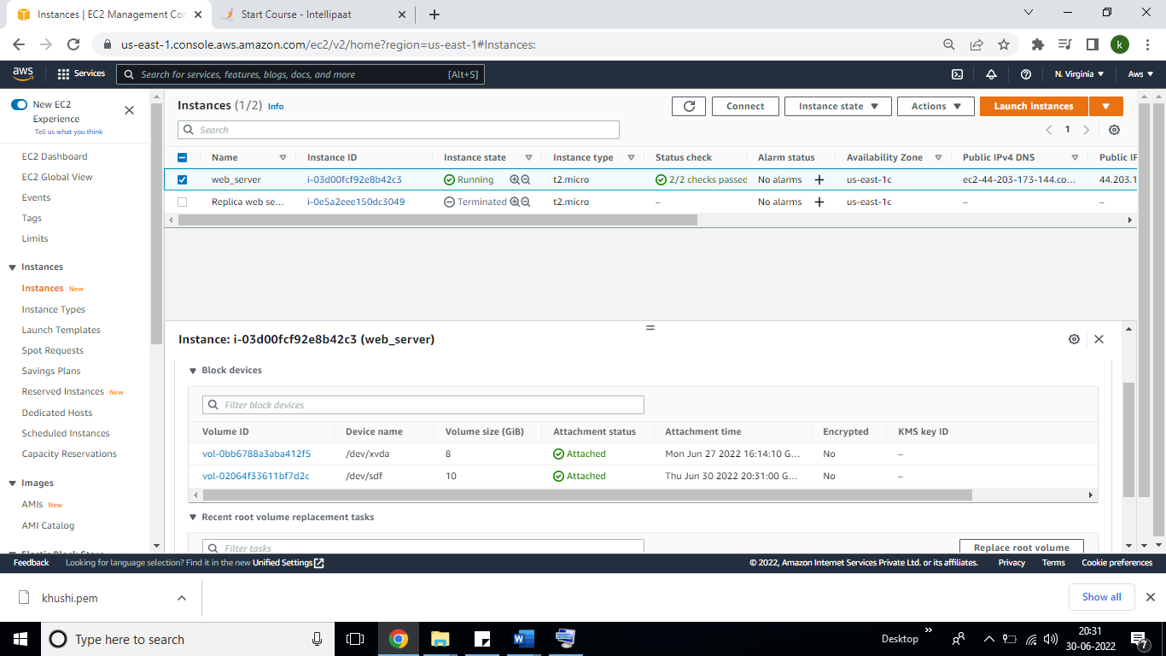

Modified the size from 10 GB to 20 GB, see the below screen shot.

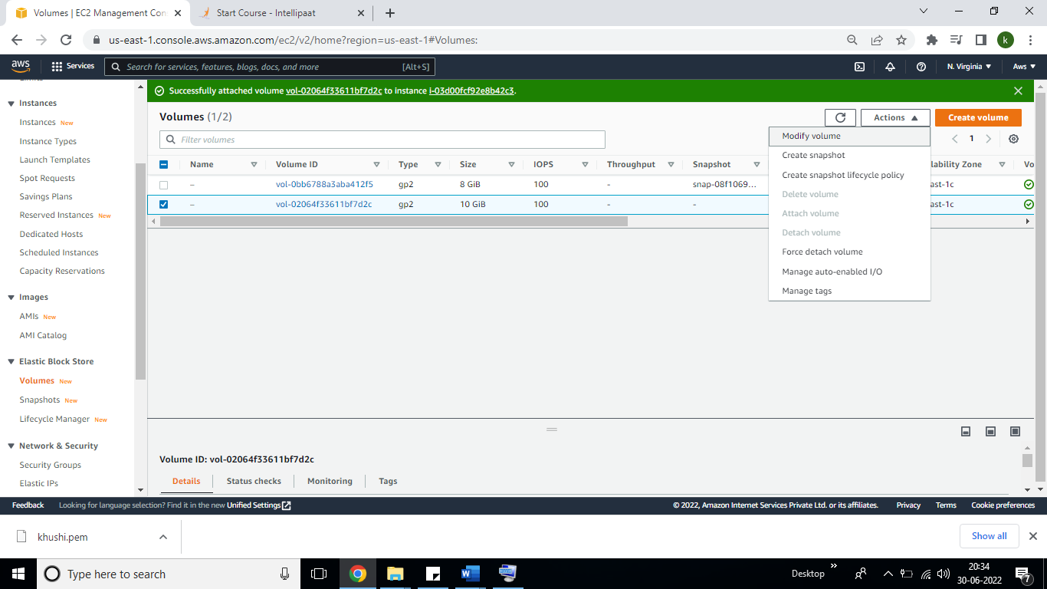

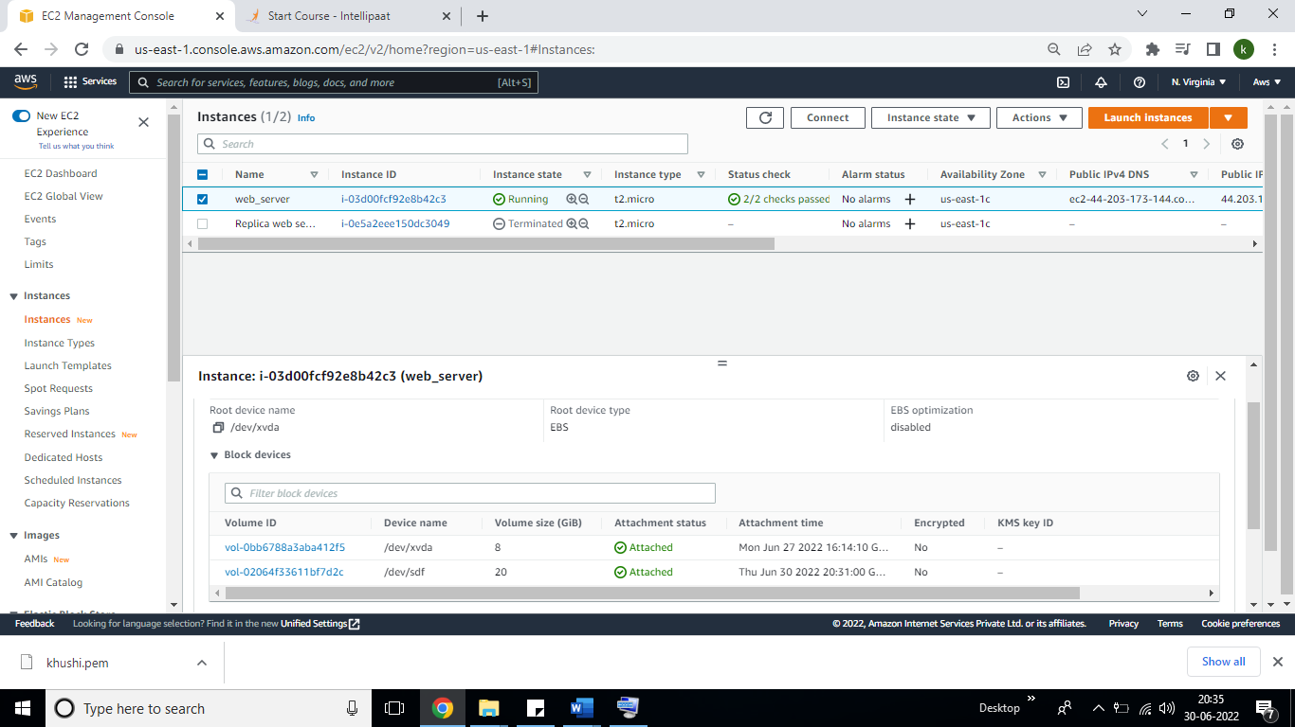

1. Take backup of this EBS volume, so click on Action—Create snapshot—create.

